Goose Creek Acceptable Mailbox Components
These are the only pre-approved mailbox components which may be used without ACC approval.
Parts purchased from any other sources MUST have ACC approval before installation.

VERY IMPORTANT NOTES FOR ALL RESIDENTS
As distributed VIA EMAIL & On Nextdoor Network in July & Aug 2020
- Mailboxes MUST have a NP-1 Number Holder Plate on top to hold address numbers
- Existing Mailboxes with Plastic Oval Number Plates do NOT currently need to replace the number holder plate, but the background MUST BE BLACK. Future replacement of the Number Holder Plate MUST be with NP-1 below.
- Only 2” Brass Numbers may be used and MUST be placed in the Number Holder Plate.
- Existing mailboxes with sticker numbers of any type placed on the Number Plate, Mailbox or Pole MUST have all numbers removed and replaced with proper Brass style numbers below.
- Plastic mailboxes of any type are NOT acceptable.
- Parts may be ordered directly from Mr. Mailbox 850 544-9207 (call for pricing) or from sources noted below. Parts from any other sources MUST have ACC approval before installation.

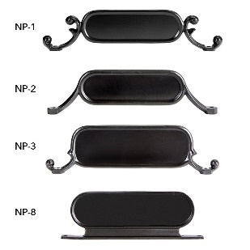
Mr. MAILBOX REPLACEMENT PARTS
Number Holder Plate
NUMBER PLATE HOLDER NP-1 is REQUIRED
Imperial Number plate NP 1

Brass Numbers
2” Brass numbers are REQUIRED and must be placed ON the Number Plate Holder NP-1
Self-Adhesive 2" Inch Imperial Brass Mailbox Number
(These numbers may also be purchased on Amazon)
https://www.amazon.com/Self-Adhesive-Imperial-Brass-Mailbox-Number/dp/B07G65CHNK/ref=sr_1_16?crid=3136DU44MUKX4&dchild=1&keywords=2+inch+brass+numbers+for+mailbox&qid=1595452446&sprefix=2+inch+brass+numbers%2Caps%2C193&sr=8-16

Post, Scroll or Ball
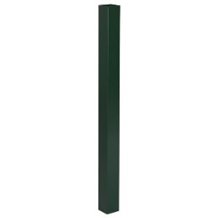
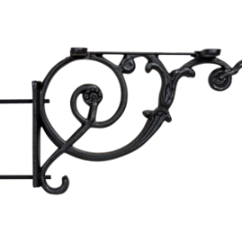
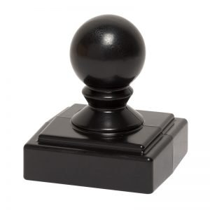

Ball Finial Imperial Y Bracket Scroll Standard Post
*****************************************

Approved Alternative Replacement Combination – Post, Scroll and Ball
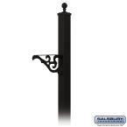
HOME DEPOT -
Salsbury Industries

Victorian In-Ground Mounted Decorative Mailbox Post in Black - $118.34
https://www.homedepot.com/p/Salsbury-Industries-Victorian-In-Ground-Mounted-Decorative-Mailbox-Post-in-Black-4845BLK/202496554

Approved Mailboxes
WALMART - $13.97

Gibraltar Classic Medium T1S00B00
$13.97 (2 day delivery or free pick up)
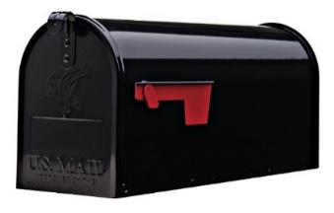
https://www.walmart.com/ip/Gibraltar-Mailboxes-Classic-Medium-Steel-Post-Mount-Mailbox-Black-T1S00B00/503031755
20.10 x6.90 x 8.9
Gibraltar Elite Medium E1100B00
$13.97 ($19.48 at Home Depot & Lowes)
https://www.walmart.com/ip/Gibraltar-Mailboxe-Elite-Medium-Steel-Post-Mount-Mailbox-Black-E1100B00/19868760
20.50 x 7.25 x 9.00 Inches
*****************************************

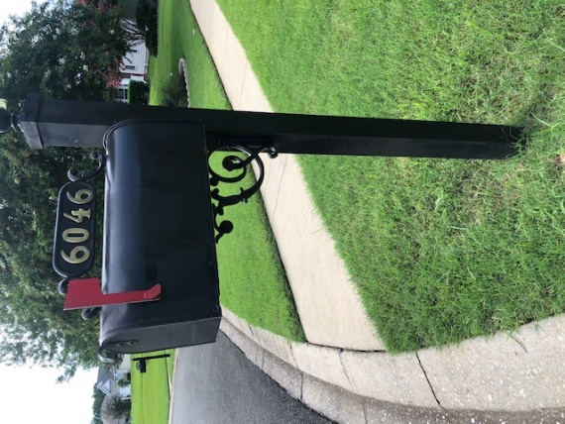

Approved/Standard Goose Creek Mailbox Sample

